Embedding collaboration: Uttar Chakwakheti (UC) readies for action
(Reflections)

The background
UC has been a delayed entrant as DSI4MTF’s research site. Besides, conforming to the multiple indicators, in right combination, the village was considered convenient for the Uttar Banga Krishi Vishwavidyalya’s (UBKV’s) extension programs. Entry, therefore, was through the UBKV route which followed a conventional extension perspective –‘some useful demonstration would be laid for the farmers benefit’. Visits after visit were made and some farmers agreed for participation. The bio-physical assessment was made and technologies planned-‘which were considered appropriate’. Because the participation was based on external support dependency was manifested in many ways. To catch up with the project goal and time line three clusters for collective farming were also identified for which farmers agreed in general. We kept interacting with the farmers and monitoring the dynamics of their participation and collectivization. At the end of the cropping cycle we sat with the farmers for reflection and comprehensive review and planning for Rabi. Followings emerged from the villagers:
- The technologies are in place which is a new hope for us
- We worked in bits and pieces and no promised support was available
- Some of us, however, tried new crops-cucumber and beans –it is a new experience
- There is no sense of cooperation among the farmers
- Maintenance of the technology is big issue-we got pumps but there are operational issues which we don’t know how to handle, the solar system broke down and so and so forth.
- The registration of the farmers club is lingering and we are just running. The external institution, identified and recommended by the UBKV, promised support but the agency they recommended for support does not even pick-up our phone.
The above offered us insight into what probably was urgent and we should attend first. We discussed with the community further and made it clear that the project is not to deliver you something at your door steps. We need to work together and explore what could be possible within the existing political economy and governance. It was pointed out that the farmers will have to be proactive and come forward. They should attend the meetings at least. A next day was fixed for further discussion.

Facilitation team’s understanding

- Missing trust in promises made
- Resulting into missing seriousness –‘they come and go –no body keeps promises’
- Communities’ own priority of eking out a living –‘these are waste of time’
- Lack of collective concerns –let us take care of our own affairs
- Perception of insurmountable vulnerabilities -‘wild life interference’
- Our life has been like this and will continue like this –‘change does not seem coming’

The follow-up meeting
The follow-up meeting is organized according to their convenience and suggestion. The attendance is quite impressive qualitatively. Those who were not seen earlier showed up including two teachers and members of the self-help groups. The discussion began on specifics:
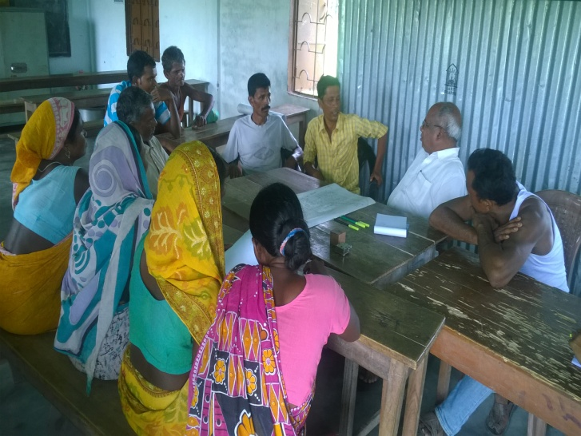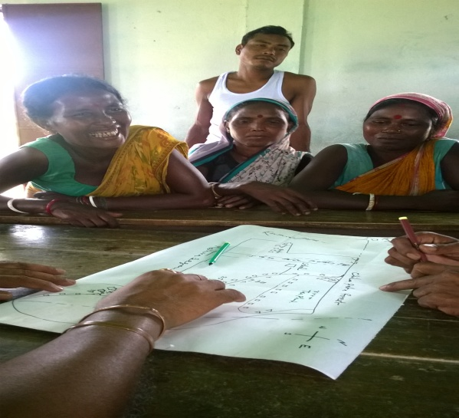
Pic: Meeting and typology mapping on 7th Oct 16 at UC
Typology: Who are there in the village that form distinct categories? According to the community members it can be divided around landownership:
Category I –Farmers with land ownership between five and 15 bighas –majority
Category II-Farmers with land between 15-25 bighas
Category III-Few families earlier settlers -50 bighas plus
No landless farmer in the village.
They have mono-crop because of lack of irrigation. Earlier efforts at diversification have been painful. Maize and wheat had bumper cropping but were trampled by the wild elephants. There is cultural inclusiveness which goes beyond land ownership. The above category of farmers have similar cultural practices and social behaviour. Except farmers in category III and II others (cat I) do not cut trees from the forest and do not have sand quarrying activities. The elephants pose similar vulnerabilities for everybody –efforts at diversification gets subdued.
Agriculture: Farmers practice mono-crop. They do not have access to technology and other support system from the government or non-government agencies. There is dependence on peer groups and fellow-farmers in and around the village. But the benefit of scientific institutions is not reaching .
Identity as tribal: A tribal household will not be able to access facilities and support from the government unless it has certificate of caste issued by the government. Around 70% of them do not have caste certificates. It is difficult and cumbersome to obtain as it undergoes a complex process. Several of the government schemes and programs cannot be accessed. Their interest is more in getting certificate than doing experiment –plain and clear.
Education for the tribal children: We have school in the village but the quality is abysmally low and our children are not interested. They definitely attend but it is just following a routine.
Institutions: There are six self-help groups but the internal governance is notional and not conducive capacity development and meeting the credit needs of the people. Also the new format is cumbersome and complicated. There is Panchayat and a co-villager (woman) is a Panchayat head. She needs to be on board if the facilities are to be streamlined and made accessible to the poor. The project cannot be successful if she is not involved.
Policy : The policy perspective of the government is in their (Tribal communities) favour but they are not able to benefit from them. For example the basic to availing facilities is their caste certificate which follows a cumbersome process and is difficult to obtain. Considering their level of education and culture of silence it is difficult to pursue.
Non-compatible priorities
The follow-up meeting led to certain basic questions:
- Do the project and the community have compatible priorities?
- Given the nature of our project, being research focused, does it offer any attraction to the community which suffers survival issues?
- Given that they have often been exposed to such grand research agenda and designs, mostly by the university and the research institutions, with no result can we win their confidence and collaboration?
- One of the teachers from the local school expressed his displeasure over a signboard put at the entry of the village terming the village as an adopted village. He was visibly confused. Who has adopted us and how we can be adopted? These games really spoil the spirit of trust and collaboration.
- At the same time ours’ is research project and it has limitations. We cannot offer any tangible inputs. We are dealing with knowledge. So how can we work out respectable arrangement for collaboration?
With the above questions we hunched:
- We cannot ignore the basic needs and priorities that the community have but at the same time we cannot/and should not offer promises, largesse and doles.
- What possibly we can do is to help reflect around their entitlements and possibilities and what they themselves can do-reminding their unique potentials!
- We could begin with basic issues and priorities and let them have a long term view of the project viz-a-viz those issues. We can establish a long term link in what our project is all about and what it can do to match with some of their priorities,
- We could evolve possible link with local resources and opportunities within the project to evolve further opportunities and help them have a longer vision and design,
- As an entry point inputs we should begin on a pleasant forum and carefully see how it goes.
A comprehensive platform for dialogue –evolving an agenda
With the above objectives in mind we carefully discussed an agenda for a larger reflection some day. Seeing our consistency the community sat with us to work out an agenda for the next meeting . Our emphasis was that the community should learn to take the responsibility for change in their hand. For example if the issue of caste certificate is serious there is a need for somebody to prepare a list. The village teacher agreed to do it and complete the same before the next meeting. The community leaders must ensure participation of maximum number of community members. We agreed to invite farmers from the nearby Dhoulaguri to let them share with them their action plan and experience of their actions especially collective farming. The date (12, October) was decided for the meeting as it was felt convenience for them. We considered and accepted this even if this was just the next day of the festive celebration.
The 12th October meeting
The first half of the meeting was devoted to lighter activities where the children and the teachers could participate in a pleasant and creative environment. The second half was devoted to interaction and sharing with the Dhoulaguri farmers and SHG members and working out follow-up if need was felt. In the following section let us share the steps and processes:
- Playing with the children, the parents and the teachers: We decided to begin with non-intrusive , non-distressing and pleasant activity where the parents and the teachers participate. To begin with we put a long sheet of paper on a table and invite the children and parents sketch anything they wish and want. After little hesitation they poured their creative elements and filled the sheet with small little designs and pictures-elephants ,flowers, sword, local artefacts and the like . The mosaic of designs presented a proud creative contribution which everybody enjoyed –children, teachers, parents and grandparents. It was decided to have the painting mounted on a frame and displayed in the school which is also our meeting place. The community had no complaints, no sense of inferiority or fear of wild animals –it was all a celebration. The teachers confirmed :They would carry out this as part of their regular curricula and pedagogy .

Subsequent session was on group recitation. The wooden horse was eulogised to have run over water, demolishing the embankment and uniting the human beings. There was uproarious scene and the recitation continued. First Mishra began the chorus which is subsequently taken over by the students and the parents. Everybody dances with the song. The parents realize that their children are no less endowed. It also takes away stress and cynicism.

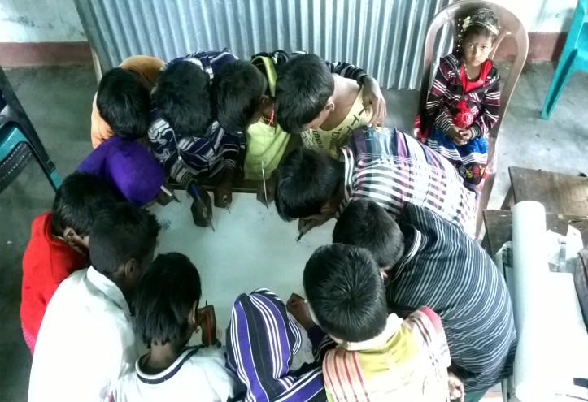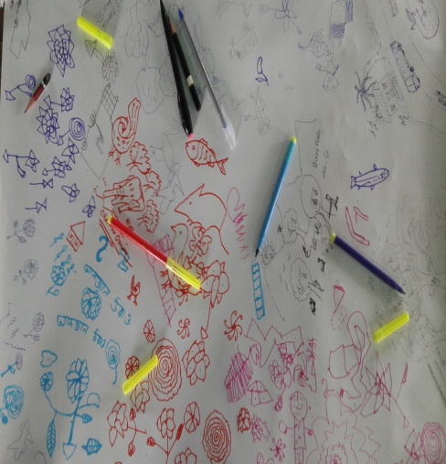
Pic: Farmers’ biggest assets: Children of UC are involved in innovative exercise

The children are asked to compose similar couplets and present. The parents focus and attention was quite visible. The children wrote couplets and stories and presented the same before the villagers who had gathered in large number. The discussion with the teachers and the parents took the following follow-up decisions:

- The painting would be mounted on the frame and put in the school. The parents would contribute for the cost,
- The stories and poems contributed by the children would be preserved by the school in its records,
- The teachers would continue with such activities in future and share the outcome with the research team during their monthly meetings,

- The lunch time : the session was followed by lunch at 1300 hours. The research team from CDHI and Prasun had the privilege of lunching with the community. There was an agreement reached on the other day. After the lunch it was decided:
- The research team would facilitate discussion and meetings and the community would offer space and food.
- The standard and quality of the food needs to be changed from being special food usually offered to guests to normal food with pulse, home grown rice and home grown vegetable.

- Field visit: After the lunch we decided to make field visit to observe the technology and field activities. We visited the Ram Prasad’s home which is at site three. Ram Prasad is also the husband of the village chief. We found:
- the pump operational
- Solar pump attended by the company with the promise to change the spare part soon,
- The field is prepared to put vegetable for which Ram Prasad brought seeds from the market rather than waiting for the external agency ,
- High return cash crops and elephant protected– Papaya and ginger grown by Ram can be cultivated at large scale in all six sites of UC and Dhaloguri.

Ram Prasad his wife Jyoti (the village head ) agreed to attend the next session of the meeting where farmers from Dhoulaguri would be visiting.
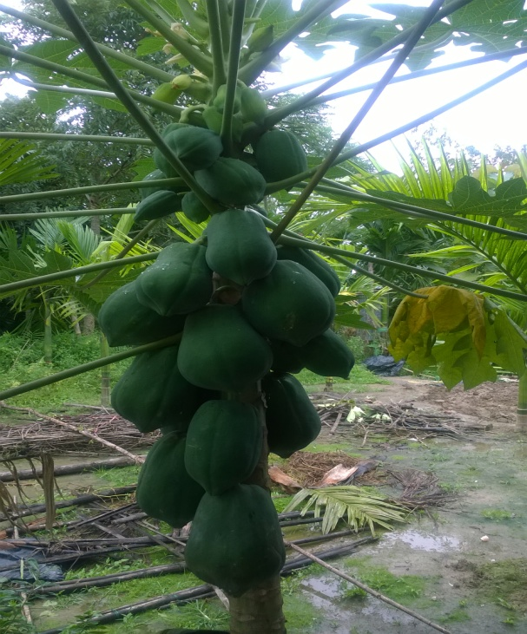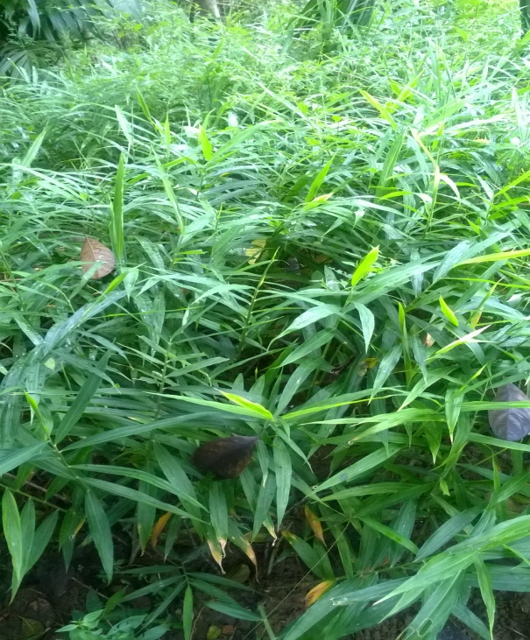
Pic: Individual farmer’s initiative-Papaya and ginger in site –II, UC to be replicated.
- The post lunch session: when we reach the venue of the meeting the hall was full to its capacity -never seen earlier. Part of the reason was children activities who had also shared their excitement with the parents. The meeting was facilitated by the research team to begin with:
Mishra Began: This is an important meeting where farmers from the two villages are exchanging their experience of a similar research initiative. Agenda for the meeting was shared with the participants which was followed strictly:
- Institutional strengthening: Dhoulaguri farmers club has gained experience and therefore would support and hand hold UC farmers club which was in a state of infancy. Responsibilities and points persons were decided. Mrinal (Dhoulaguri) offered to make necessary connects. Subhas from UC became the counterpart.
- Experiences on agriculture practices were shared. Bilal from Dhoulaguri shared his entrepreneurial journey and his present status as a farmer. UC farmers asked if they could help in crop planning and cultivation. There is arrangement for training and field visits.
- SHGs have problems in both the sites and they agreed to take this up seriously soon. Mishra will take up the issues after he returns to North Bengal after two months.
- Collective farming: Dhoulaguri has already laid seeds for chilly and UC has an action plan ready . This year UC will also try potato for which Dholaguri has adequate expertise. The two villages and contact persons would interact regularly.
- General protocol: The two research villages would work following and environment of collaboration and help to each other. Research team will facilitate coordination and capacity building and monitor the process.
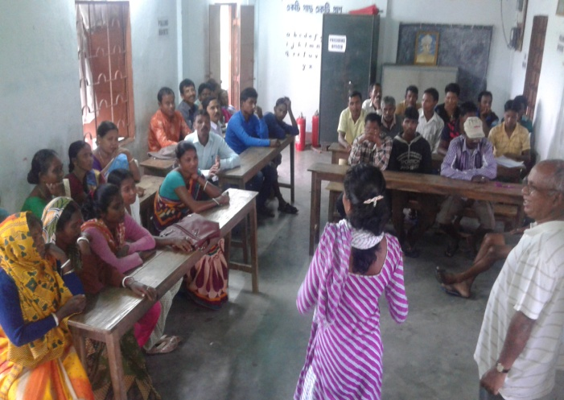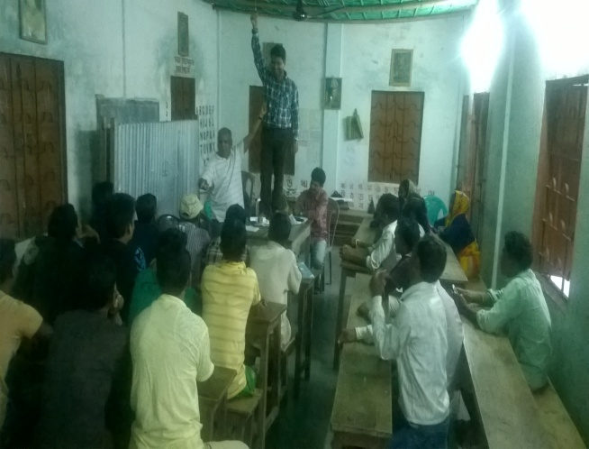
Pic: Jyoti Oran, head of the Uttar Chakowakheti Gram Panchayat /local governance is sharing her experience and confidence building session in the meeting on 12 Oct 2016
The feasibility considerations
The question of feasibility of such an exercise may be questioned and also its disconnect argued . In a research project on irrigation and crop intensification where do the children and the school figure? Our understanding is that research endeavours cannot be seen in isolation from the community reality. The compatibility and priority gap between the research and researchers and the community need to be understood. A perspective that can respect the community’s endowment is all that needs to be remembered. The facilitation needs to consider this as important condition. Components that can establish this need to be brought in the facilitation process.
Time and resources considerations
What has really been done is important to understand. The community members and local institutions have been brought at the central place and through a process of reflection encouraged to take over the lead responsibilities. The whole idea is to carefully observe this transition from researchers led and facilitated exercise to community and local institutions led enterprise. Gradually the time and resources gets reduced for the researchers and an institutional synergy seems to evolve which we need to carefully watch.
A careful action planning
To continue with continuity and phasing out, a careful follow-up action plan is needed. For example our team has fine tuned and finalized an action plan which evolved during the process of engagement for the next three months. The presence of X,Y or Z person (often called the key person) does not matter much. This key person is key only if he/she is in a position to facilitate working out a long term plan together and observe everybody working according to the agreed strategy with changes coming in as the process goes.
What does it hold for Uttar Chokuakheti?
The story told about UC is a story of indifference gradually turning into participation. Community engagement perspective and process has played a crucial role. Today’s situation in UC may be considered as followings:
- Trust in the project and confidence in themselves seem to be growing and embedding
- Confidence to act is clear
- Capacity to plan and implement is showing up
- Clarity about a long term vision growing
- Looking beyond UC –to begin with Dhoulaguri and Alipurduar .

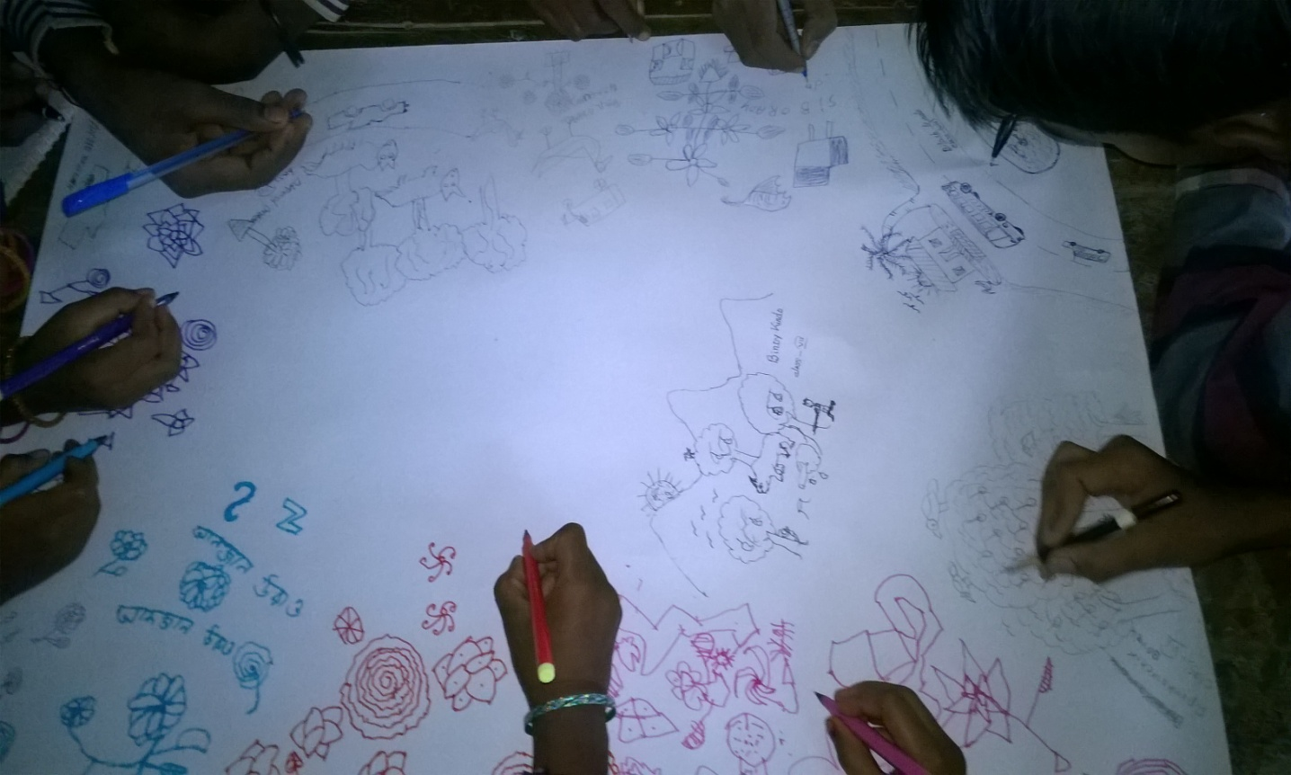
This may not happen in other places but this can not negate the impact this process has the potential for.

